Take Your Aquabeads Wherever You Go This Summer with the NEW Deluxe Craft Backpack

Introducing the latest set in the Aquabeads 'on-the-go' range – the Deluxe Craft Backpack. Whether crafting at home, off to visit friends or family, or even flying to far away shores, the new Aquabeads Deluxe Craft Backpack is perfect for keeping kids entertained during the summer holidays!
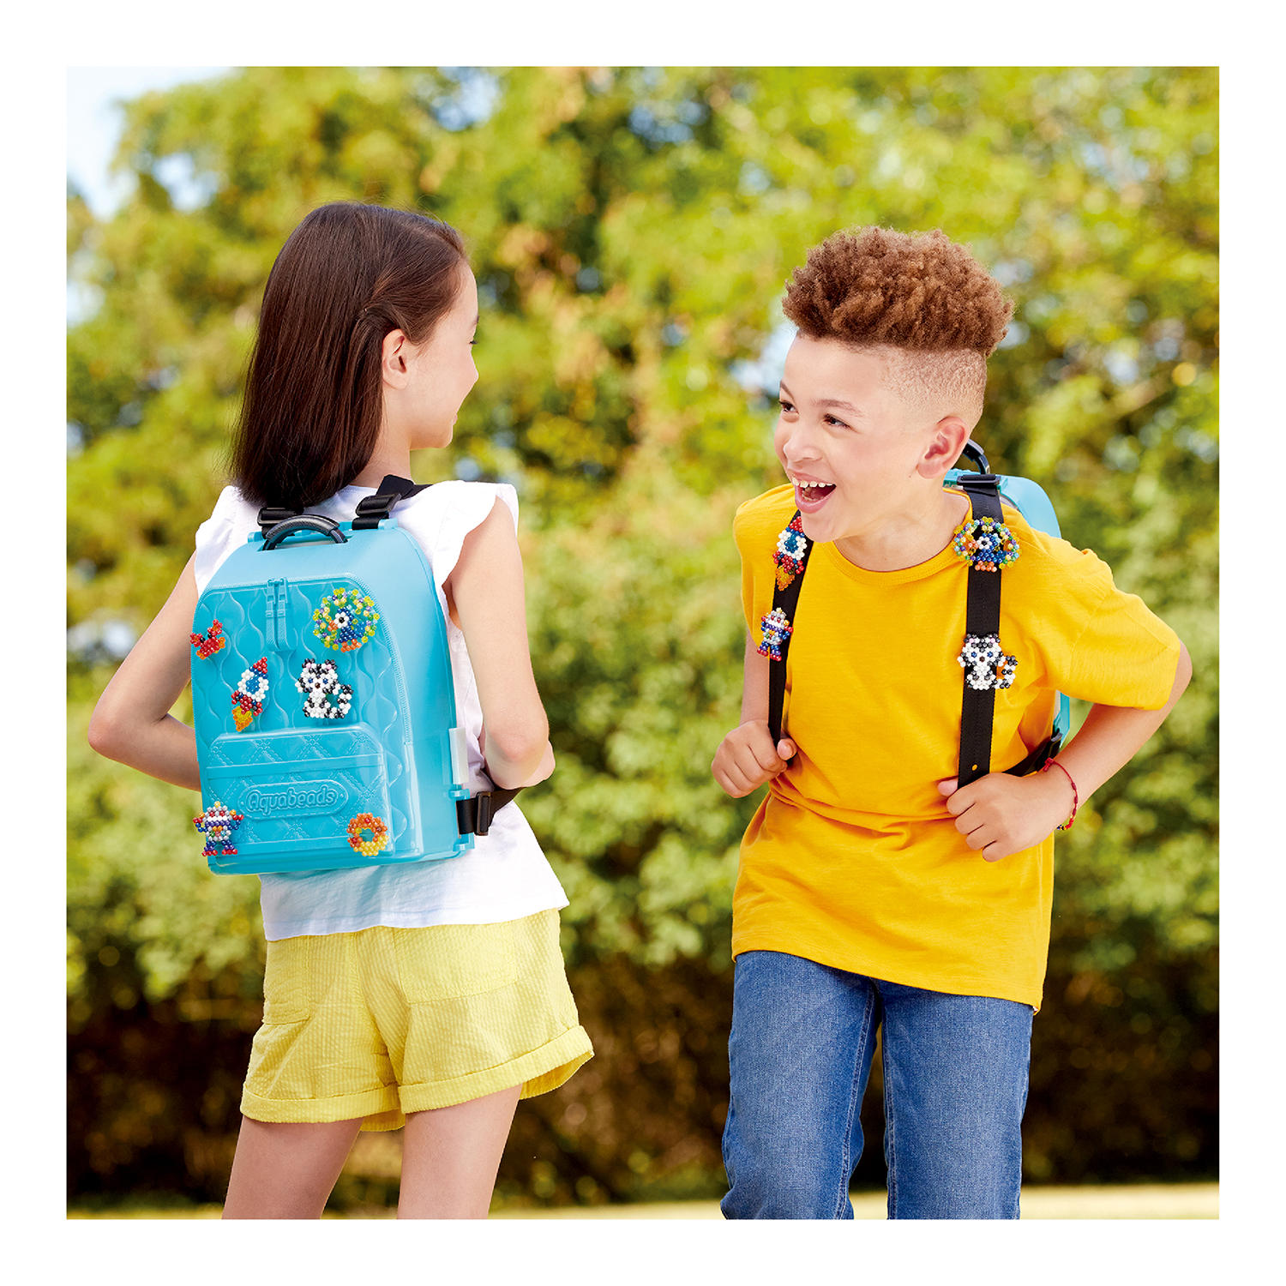
The sturdy, bright turquoise backpack features a whopping 1,000 shiny, star and solid beads in 40 different colours along with all the essential tools needed to make beautiful creations including a flip tray, double-sided Aquabeads pen, and template sheets for inspiration.

Best of all, the backpack can be fully personalised by attaching your finished creations to the outer shell and the straps!
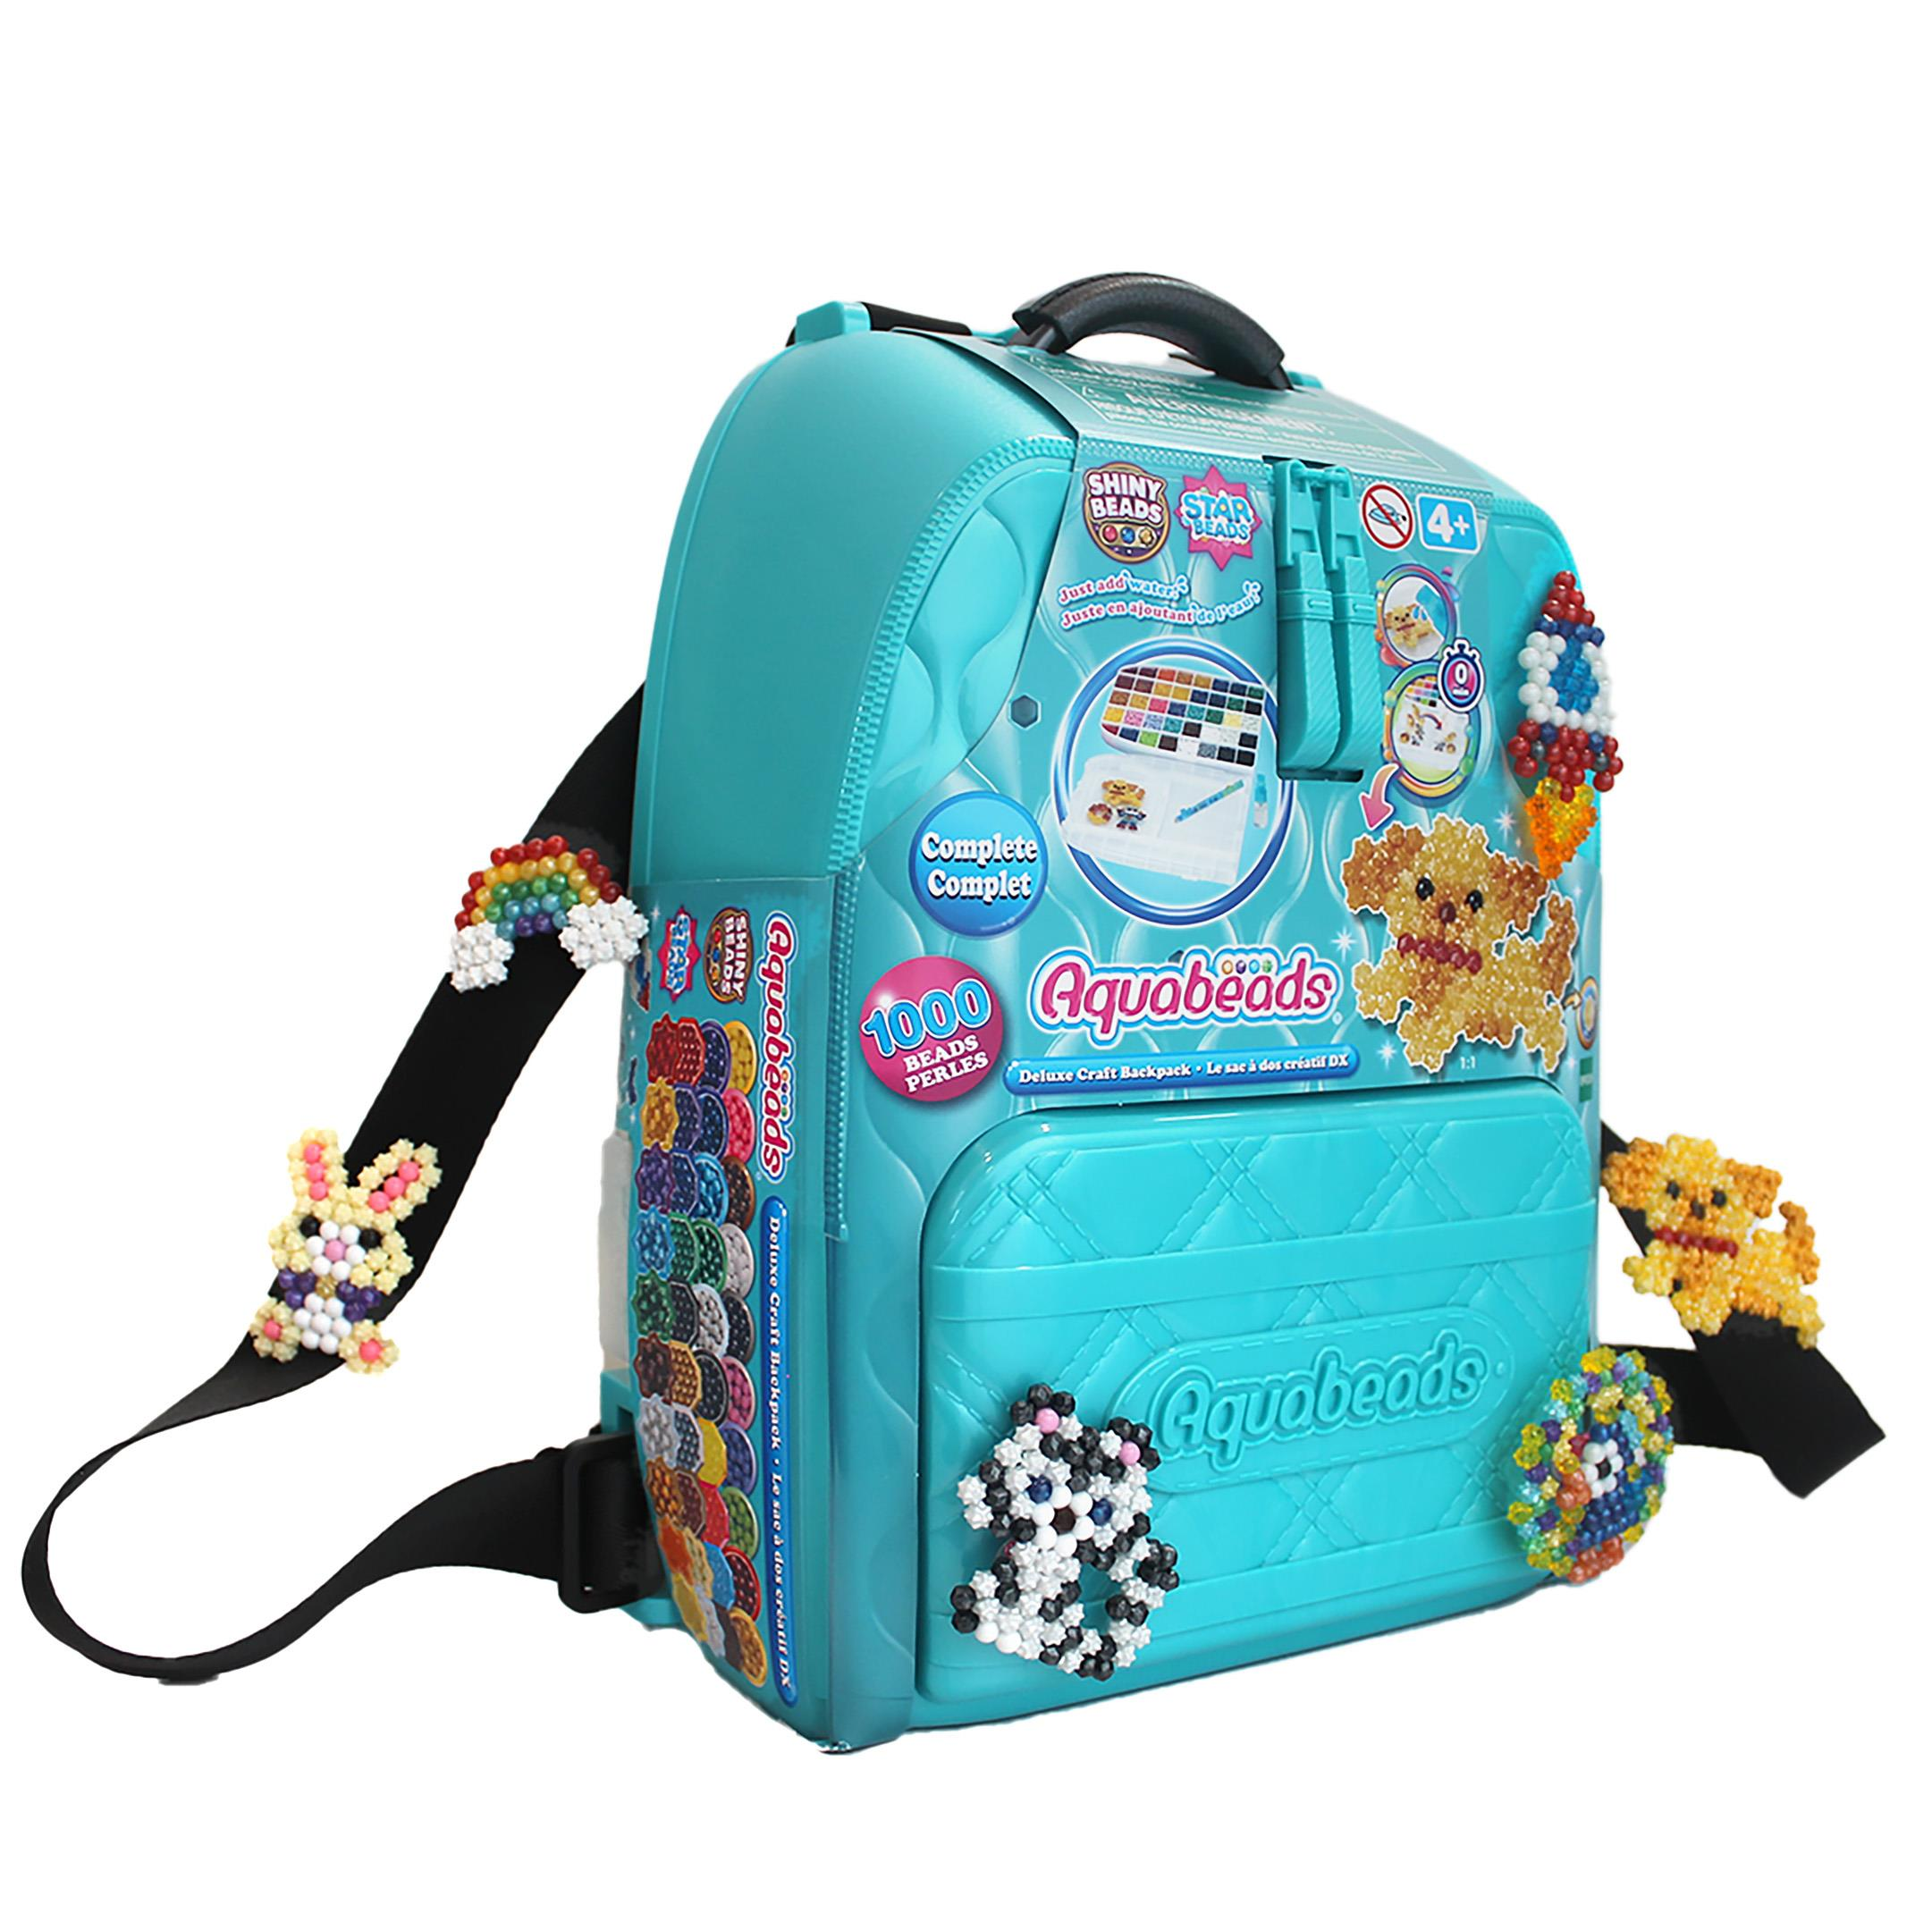
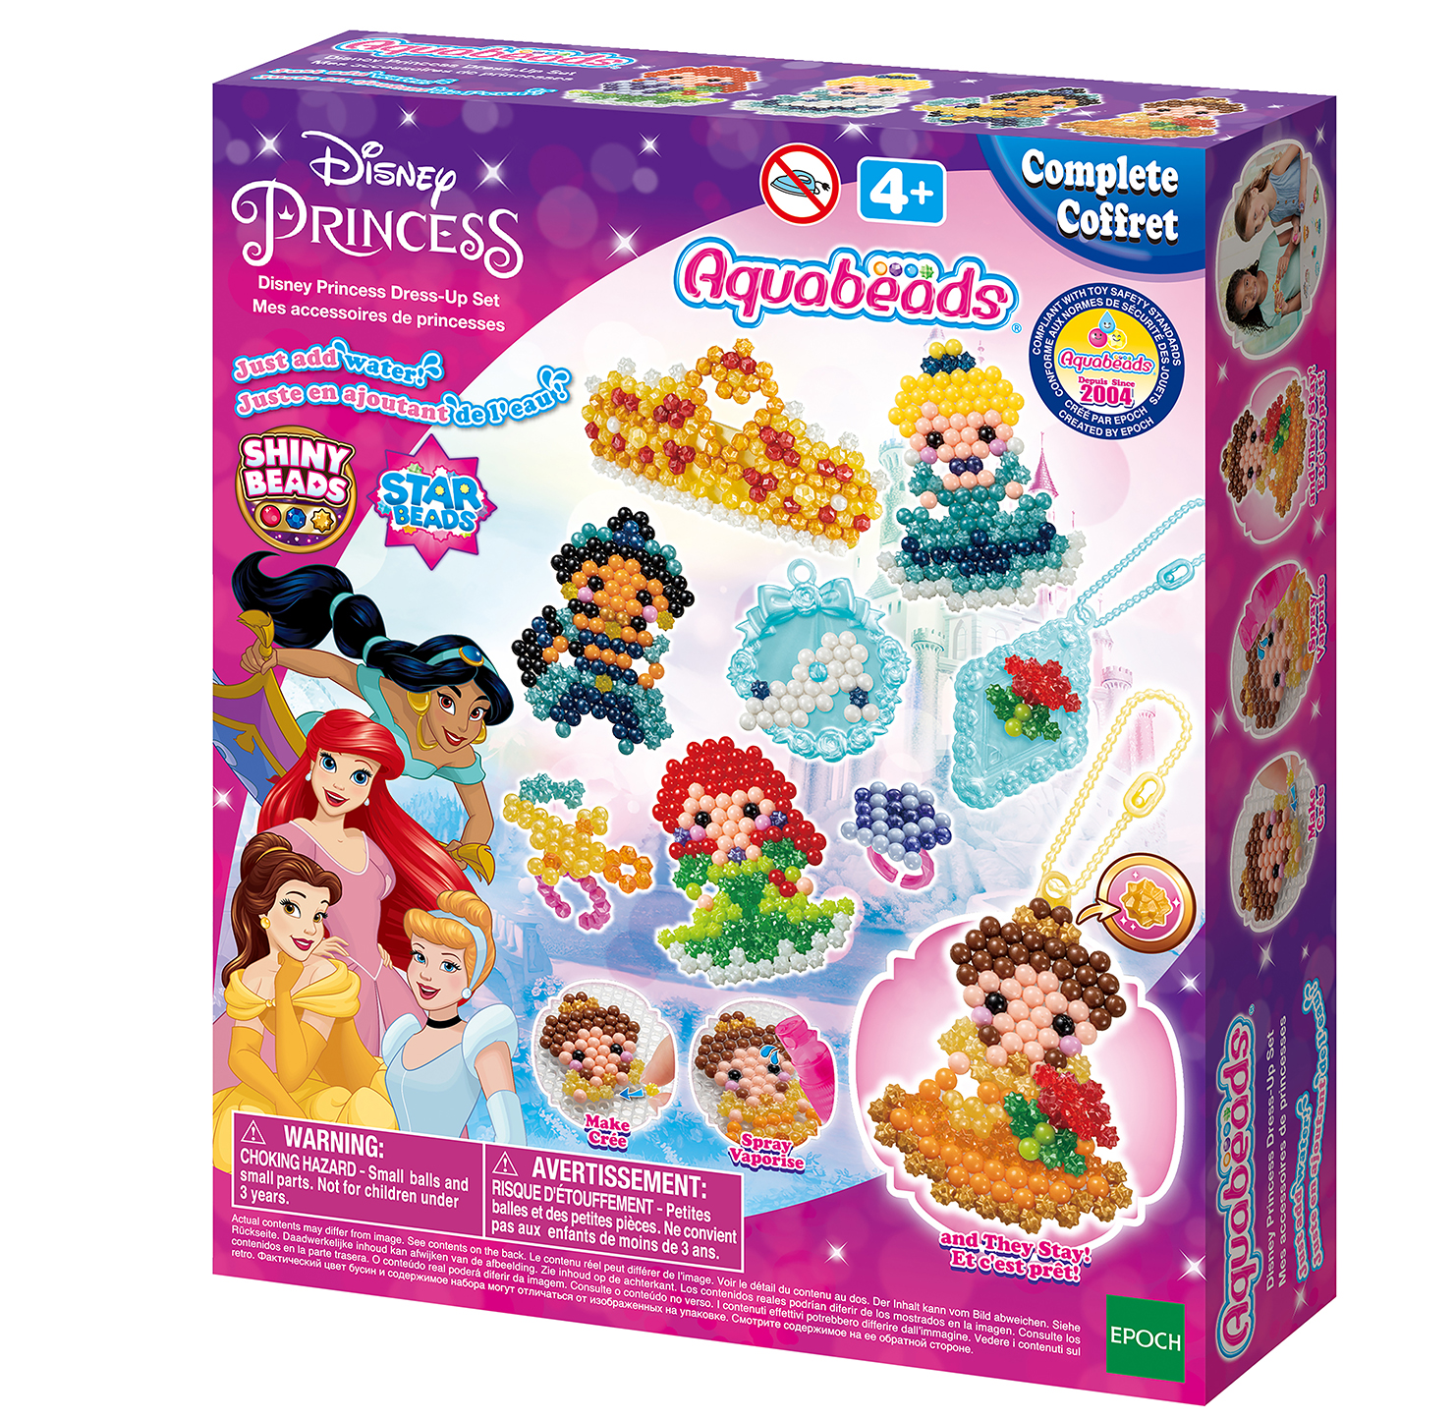
The Deluxe Craft Backpack joins the Beginners Carry Case and Deluxe Carry Case to the on-the-go range which launched last year.

Also new for this summer is the Disney Princess Dress-Up Set. Create your favourite Disney Princesses including Ariel, Cinderella, Belle and Jasmine! The set comes with over 900 colourful shiny, star and solid beads as well as keyrings, pendants and rings for making a variety of wearable accessories fit for a princess. Keep them for yourself or gift them to friends.

Aquabeads is super simple to use enabling children to craft independently. Just pick a template design, place your beads on the layout tray, spray with water and watch as they magically stick together!

Aquabeads sets are suitable for ages 4+.

Deluxe Craft Backpack, RRP £34.99
Disney Princess Dress Up Set, RRP £21.99

All products are available now from Smyths

Images downloadable HERE.

- ends –
About Aquabeads
Originally developed in 2003, Aquabeads is now sold in more than 45 countries and is the original stick-with-water bead brand. No heat or messy glue required; children can simply enjoy the creative process from beginning to end.

The sets help children to express their creativity, develop dexterity and patience with a wide range of themes to choose from such as animals, mystical creatures, flowers, and even their favourite animated movie characters!

So simple to use, just place the beads on a layout tray, follow the template, spray with water, and wait until the beads magically stick together and form an amazing Aquabeads creation.
Aquabeads is fun and safe for children 4 years and up.

For Further Information:
Please contact Playtime PR:
Claire Down – claire@playtimepr.com – 07786430077
Kelly Jones – kelly@playtimepr.com - 07717 214 040

