Introducing ZipLinx, Flip Frog, and This Side Up:
The Ultimate Christmas Gifts for Kids
Get Christmas wrapped up with ZipLinx, Flip Frog and This Side Up, just in time for the festive season. These toys and games from John Adams provide endless hours of fun for kids of all ages, making them the perfect Christmas gift.
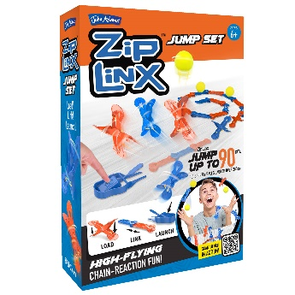
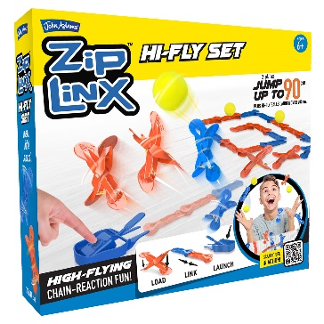
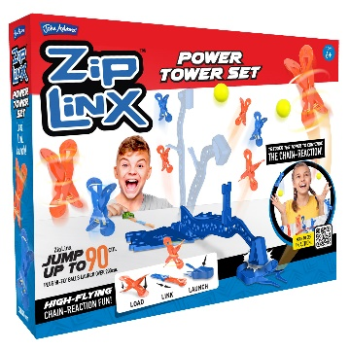
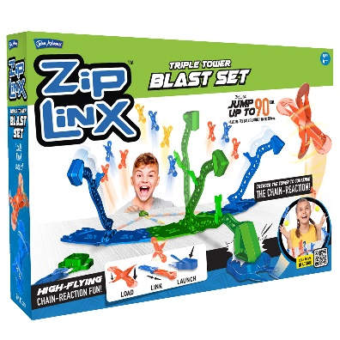

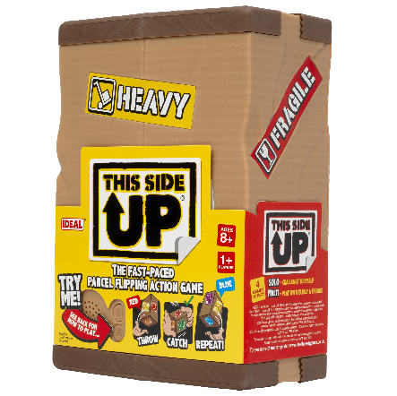
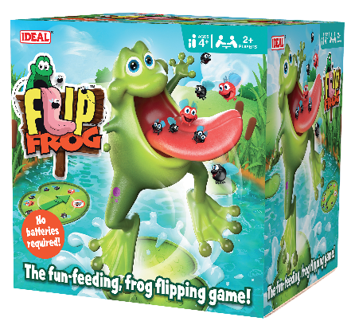
ZipLinx (SSP £12.99 - £29.99) is a system of specially designed spring-loaded linx, allowing kids to create their own amazing designs ready to launch in minutes! With one push of the launcher key, they can send their designs flying up to 90 cm into the air and record them in slow motion to see the eye-popping results. Suitable for kids aged 6+, all ZipLinx sets in the range can be combined for even more fun.
Flip Frog (SSP £19.99) is a quick and easy action game for younger family members. Spin the spinner and feed Flip Frog the number of flies indicated, but be careful not to feed him too much or he'll do a 360-degree somersault that will make you jump! Flip Frog is suitable for kids aged 4+, can be played by 2 or more players and requires no batteries, so there’s no Christmas day panic!
This Side Up (£22.99) is an addictive family reaction game, which is the perfect Christmas or Boxing Day pick-me-up. Follow the voice commands and flip the box
to the correct colour facing upwards. With four games to play, including solo and multiplayer modes, there’s a different challenge each time. This Side Up is a game that kids aged 8+ will find hard to put down. Includes batteries, so you can
play straight away!

