**HISENSE DEBUTS NEW MDA HEROES FOR 2025**

*Hisense has announced the expansion of its MDA range, featuring an evolution in smart-home appliances with integrated AI automation and premium aesthetics*

[Hisense](https://uk.hisense.com/), a global leader in consumer electronics and home appliances, has unveiled a number of new products launching this summer across its 2025 MDA lineup. Introducing a range of products across its refrigeration, dish and cooking ranges, the new models have been designed with more smart features than ever before, as well as increased energy efficiency and flexible living.

Building on its commitment to empower consumers to choose smarter, Hisense has equipped its latest kitchen solutions with enhanced connectivity through the exclusive ConnectLife app. This integration creates a seamless smart home ecosystem, allowing users to manage and monitor their appliances with greater ease, personalising their appliance functions including meal planning with the newly launched Dish Designer software, for added efficiency.

Matthew Glynn, Senior Product Marketing Manager at Hisense, commented: “At Hisense we consistently strive to innovate within the MDA sector, looking at ways in which we can offer our customers more value and benefits. By expanding the capabilities of our smart technologies, we will continue to redefine what’s possible in the modern home, delivering premium performance and intuitive functionality to households across the UK.

“Launching brand new appliances in the refrigeration, dish and cooking categories so far this year, we are pleased to introduce appliances that promote a sleek and contemporary design, without compromising on convenience, efficiency and advanced technology.”

**Refrigeration:**

**Hisense Pure Flex Fridge Freezer (RQ5P640SYSD)**

Hisense continues to lead in refrigeration innovation with the introduction of its latest model, the Pure Flex Amercian Fridge Freezer. Positioned within the premium ice-producing refrigeration category, this cutting-edge model combines elegant design with advanced technology to deliver an elevated kitchen experience.

With its sleek and contemporary flat door design that suits a wide range of kitchen aesthetics, the latest model puts flexibility first, with integrated tech-forward features ensuring convenience and efficiency that truly enhances everyday usability. With a D rating for energy efficiency, the latest model is suitable for both budget and eco conscious consumers.

Using advanced technology, the 99.9% UV sterilisation system purifies water and ice prior to dispensing, offering consumers added peace of mind with every use. The 640L model includes a dedicated compartment that produces two ice types, cubed and nugget, allowing users to customise their ice according to their beverage preferences. Additionally, a generous 5L non-plumbed water tank is equipped with a UV water treatment system that effectively eliminates 99.9% of bacteria and operates without the need for replaceable filters, unlike traditional refrigeration models, offering long-term convenience and sustainability.

Beyond the model’s impressive ice-making capabilities, the Pure Flex fridge freezer also delivers on storage innovation. Its spacious four-door design includes adjustable cantilever sliding shelving which can be split at different levels to accommodate large or bulky items with ease, without having to change the whole fridge configuration. The refrigerator can be arranged into three distinct compartments, including the versatile 'My Fresh Choice' zone, which allows users to convert the space from a fridge to a freezer with temperature settings ranging from -18°C to +5°C.

To further enhance food preservation, the integrated 'Cool Fresh Box' maintains a consistent temperature range of 0°C to 3°C, ideal for storing meat, fish, and fresh produce while ensuring optimal freshness and extended shelf life.

**RRP: £1499.99**

**Stockists include: Curry’s, AO**

[**Hisense French Door Refrigerator (RF632N4AIC1)**](https://uk.hisense.com/products/cooling/freestanding-refrigerators/french-door-refrigerators/REFRIG-BCD-454WY-RF632N4AIC1-HSN/p/000000000020011716)

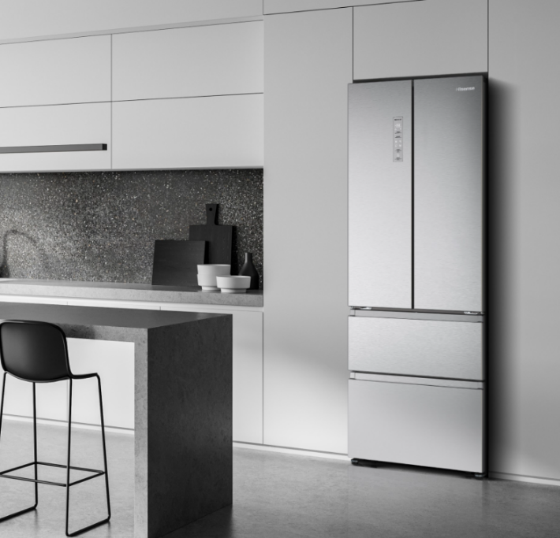

Never one to compromise on aesthetics, Hisense has also launched a brand-new French door refrigerator as part of an extension to the existing RF632 PureFlat Slim Series. This model combines cutting-edge cooling technology, generous storage, and sleek styling. Thoughtfully designed to suit the demands of modern households, this freestanding fridge offers both form and function in equal measure, all without compromising on energy efficiency. With a 2M height and 70cm depth, this impressive model maxmises food storage when kitchen space is often at a premium, without compromising on floor space.

At first glance, the brushed stainless-steel finish lends a contemporary touch, perfect for kitchens with a modern edge. But beyond its good looks, the RF632N4AIC1 has an energy efficiency C rating and houses some seriously clever cooling features. This means it not only helps to reduce on carbon footprint but can also lead to noticeable savings on energy bills over time, a win for both the environment and the consumer’s wallet.

Central to the fridge’s performance is its **‘**Metal Tech Cooling’ system, stabilising the internal temperature and keeping food fresher for longer. Consistent airflow is maintained throughout the cavity, and thanks to ‘Total No Frost’ technology, the fridge stays ice-free without any manual defrosting every shelf and drawer is reliably chilled.

With a spacious485-litre capacity, there’s room to spare for everything from fresh produce to frozen meals and party platters. Elegant French doors open to reveal a bright, well-organised interior. User-friendly touches include a sleek LED display, allowing precise temperature control, and a door alarm to prevent energy waste from accidental open doors.

This stylish fridge also includes humidity-controlled crisper drawers, ideal for prolonging the life of fruits and vegetables, the ‘Super Cool’ function helps rapidly chill newly added items, locking in freshness for longer.

**RRP: £1,099**

**Stockists include: Currys, AO**

[**Hisense American-Style Fridge Freezer (RS9P628GPFE)**](https://markselectrical.co.uk/rs9p628gpfe_hisense-american-fridge-freezer)

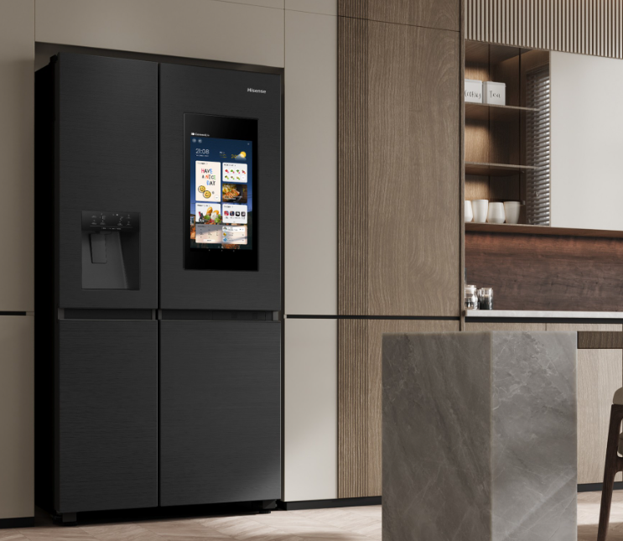

For families craving both space and style, Hisense introduces its newest American-style fridge freezer to its smart screen refrigeration family, which delivers on all fronts. Boasting a substantial 628-litre capacity, this appliance makes light work of stocking up, whether it’s for a big household shop or entertaining guests.

Its plumbed water and ice dispenser brings cool convenience without the installation fuss, while ‘Total No Frost’ and ‘Multi Air Flow’ systems ensure consistent cooling and ultimate freshness in even the most packed fridges.

Delivering on aesthetics and style, the model features Hisense’s signature Pureflat design, with a sleek flat door front and subtle recessed handles, suiting a variety of kitchen interiors from ultra-modern to traditional homes. The patented Eclipse Dark interior is not only stylish in its design, but also eliminates 99.99% of harmful bacteria, ensuring stored food remains fresh and hygienic.

The refrigerator boasts AI smart connectivity with Hisense's exclusive Connectlife app, with usability enhanced by the 21-inch touch LED smart screen that enables users to take advantage of the food inventory function for meal planning, message board, shopping list and screen sharing, adding convenience and functionality to everyday modern life.

The RS9P628GPFE model is also fully compatible with Hisense’s newly launched Dish Designer software upgrade, this AI-powered meal planning tool offers creative recipe suggestions, inventory management, alignment to nutrition goals and even considers dietary restrictions. With convenience at the heart of the development, users can input time constraints and preferred effort levels, with Dish Designer generating matching recipes ranging from a variety of cuisines and can be tailored to specific events, from Monday night meals to weekend dinner parties.

**RRP: £2,099**

**Stockists include: Curry’s, AO, and Marks Electrical**

**Cooking:**

Hisense is turning up the heat in the kitchen with the launch of its latest cooking innovations: a sleek new range of cooker hoods and a high-performance induction hob. Designed to meet the demands of modern home cooks, the new collection combines functionality with streamlined style, offering powerful extraction and effortless integration into any contemporary kitchen.

[**Hisense Angled Chimney Hood (CH6IN14BXBUK)**](https://uk.hisense.com/products/cooking-and-baking/all-hoods/wall-hoods/HOOD-CV60BK-F-N2T5Q-CH6IN14BXBUK-HSN/p/000000000000745122)

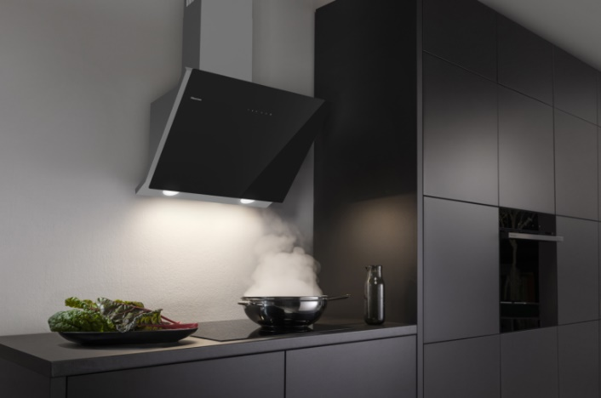

This chimney hood is a stylish solution for keeping your kitchen fresh, clean, and modern. With its striking black glass finish and angled design, it’s made to stand out or blend seamlessly into a contemporary cooking space.

Designed to tackle steam, smoke, and lingering cooking odours with ease, this hood offers powerful performance without the noise. Whether you’re searing steaks or simmering sauces, it quietly clears the air so you can enjoy your kitchen the way it’s meant to be, as the hub of the home.

Touch controls make adjusting the fan speed feel effortless, while the clever timer function means it switches off automatically when it’s done, so you don’t have to give it a second thought. Plus, with the option to install it with or without ducting, it’s as flexible as it is functional. Sleek, smart and made for modern living, this is everyday freshness, elevated.

**RRP: £259.00**

**Stockists include: Curry’s, AO, Boots, and Marks Electrical**

[**Hisense Chimney Cooker Hood (CH6T14BBUK)**](https://uk.hisense.com/products/cooking-and-baking/hoods/HOOD-CS60BK-A-N2T5L-CH6T14BBUK-HSN/p/000000000000745124)

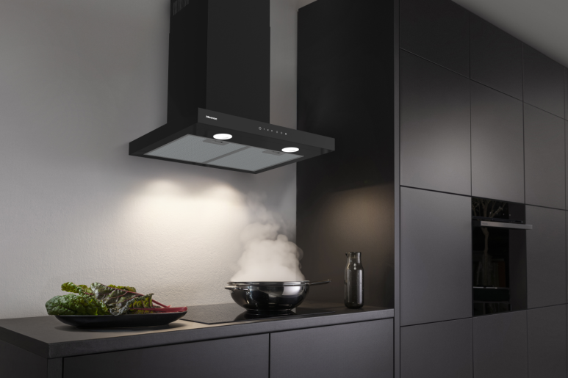

For a more aesthetic yet practical option, the chimney cooker hood is a sleek, modern upgrade for any kitchen. Its clean T-shaped design and smooth black glass touch controls bring a stylish, high-end finish to your cooking space.

It’s built to quietly clear the air while you get on with everyday cooking, keeping unwanted steam and smells at bay so your kitchen stays fresh and comfortable. Simple to use and easy to install, it offers flexible ventilation options to suit your space, whether you’re remodelling or refreshing your space.

Soft LED lighting adds a subtle glow over the rest of the cooker, while intuitive touch controls make adjusting the settings effortless. It’s energy efficient too, so you get standout performance that’s kinder on your bills.

**RRP: £199.00**

**Stockists include: Curry’s, AO, and Boots**

[**Hisense Electric Induction Hob (HI6442BSCWF)**](https://uk.hisense.com/products/cooking-and-baking/all-hobs/induction-hobs/HOB-BI6AC-S1-HI6442BSCWF-HSN/p/000000000000744164)

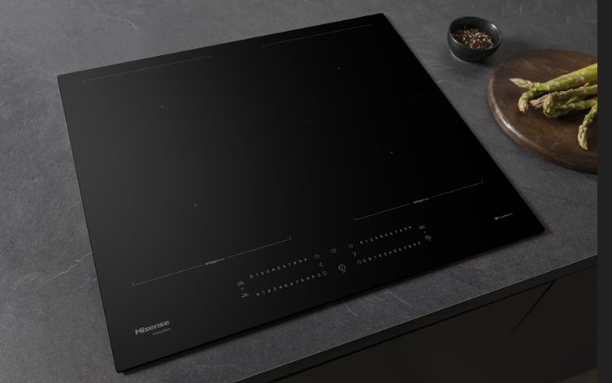

Hisense’s latest hob model showcases the brand’s most advanced cooking technologies to date, designed to deliver precision, flexibility, and ease of use. This induction hob combines sleek design with smart functionality, making it a standout addition to any modern kitchen. Its frameless black glass surface and intuitive touch controls offer a minimalist aesthetic that's both stylish and easy to clean.

Equipped with four induction zones, this hob ensures rapid and efficient cooking. The innovative Area Flex feature allows you to merge two zones, accommodating larger pots or griddles with ease. From searing steaks to boiling pasta, the Rapid Boil function delivers intense heat quickly, then automatically reduces to a simmer after five minutes for optimal cooking results.

The intuitive slider controls provide precise temperature adjustments for each zone, while the Heat Shift function lets you seamlessly move pots across zones without interrupting the cooking process. Safety is paramount, with features like residual heat indicators and a child lock ensuring peace of mind during use.

Insta Detect, another new technological addition, delivers ultra-fast pan recognition in under 0.2 seconds, automatically transferring settings between zones for seamless control, even when moving cookware. Complementing this is Hisense’s new Gentle Heat Technology, which maintains consistent low temperatures ideal for delicate tasks like melting chocolate or slow-cooking stews, ensuring flavours and textures are perfectly preserved.

With its combination of advanced features and elegant design, the Hisense HI6442BSCE induction hob offers both performance and style, enhancing your culinary experience.

**RRP: £529.00**

**Stockists include: Appliance City**

**Dish:**

There’s no stopping Hisense with its latest dishwasher, designed to take the effort out of everyday cleaning. With advanced features, intuitive programmes and sleek styling, the new model offers powerful performance with minimal water and energy use, making light work of post-meal clean-ups while blending seamlessly into the modern kitchen.

**Hisense Integrated Dishwasher (**[**HV693A60UVADUK**](https://uk.hisense.com/products/dishwashing/built-in-dishwashers/DISHWASH-DW50-2-HV693A60UVADUK-HSN/p/000000000000745714)**)**

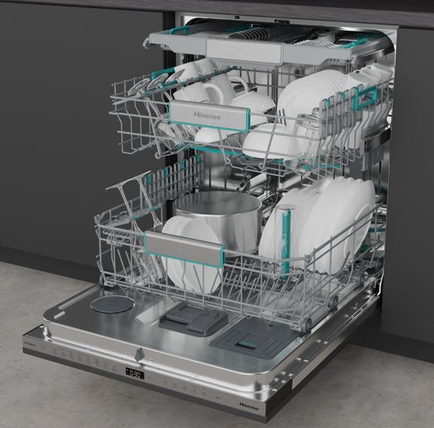

This dishwasher is designed to deliver powerful performance, sleek integration and everyday convenience all with a premium finish. With space for an impressive 16 place settings, it’s ideal for larger households or entertaining.

Blending beautifully into any kitchen, the fully integrated design is paired with intuitive touch controls and a stylish new colour interior that brings a modern touch to the heart of the home. Inside, adjustable baskets and a dedicated top cutlery tray offers maximum flexibility, so you can easily fit everything from tall stemware to wide pans in a single load.

Equipped with advanced UV and ion technology, the HV693A60UVADUK goes further than a standard clean neutralising bacteria and mould for superior hygiene. Built-in WiFi Connectivity allows you to control and monitor your dishwasher remotely via the Hisense ConnectLife app, adding a smart edge to your routine.

With a powerful yet quiet inverter motor, energy-efficient A rating, and seven versatile programmes, it’s the ideal upgrade for kitchens where style and substance go hand in hand.

**RRP: £799.00**

**Stockists include: Curry’s, AO, Very and Appliances Direct**

To find out more about the Hisense’s products, visit: <https://uk.hisense.com/>

**ENDS**

For more information, please contact the Hisense UK team at Hatch: [hisense@hatch.group](mailto:hisense@hatch.group) / 0113 361 3600.

**About Hisense**

Founded over 50 years ago in China in 1969, Hisense is a leading global home appliance and consumer electronics brand and was Official Partner of the UEFA EURO 2024™, following on from past tournament sponsorship in 2016 and 2020, and a successful sponsorship of FIFA World Cup 2022™.

Hisense UK is headquartered in Leeds. The brand has a core range of televisions and cooling appliances, alongside a portfolio of cooking and laundry products, featuring hobs, hoods, ovens, dishwashers and washing machines.

According to Omdia, Hisense ranked No. 2 globally for TV shipments and No. 1 in 100" TVs in both 2023 and Q1 2024. The company has expanded quickly to operate in more than 160 countries and specialises in multi-media goods, home appliances, and intelligent IT information. Hisense continuously invests in research and development and has over 100,000 employees worldwide. For more information visit <https://uk.hisense.com/>.