80% of British Women Wearing Wrong Bra Size
Nudea Leading The Way To Getting Perfect Fit

It’s an oft-quoted statistic that 80% of British women are wearing the wrong bra size, but at last a lingerie brand is modernizing the measuring process. With almost 50% of women admitting that they’ve not been measured for a bra in over 5 years*, Nudea, www.nudea.com is on a mission to revolutionise the way that women can find their perfect fit. To make life easier and bras fit better, Nudea has invented a bespoke tape measure. Created with the expertise of one of the UK’s leading bra fit experts, the tape allows for accurate, hands free measurement quickly and simply at home.

Carlotta Ghigi, Nudea’s in-house bra technologist and expert fitter, has personally fitted thousands of women over her 20-year career in the intimates world. According to Carlotta, the most common problem is women wearing bras with an underband that’s too big. She explains that comfort is personal to everyone and some women choose a looser underband, so they don’t feel constricted. However this means that the bra isn't holding onto the body as much as it should – it’s actually the underband that does all the hard work supporting the bust, not the straps. It should feel snug against your skin, resting in a straight line across the back with no digging in.

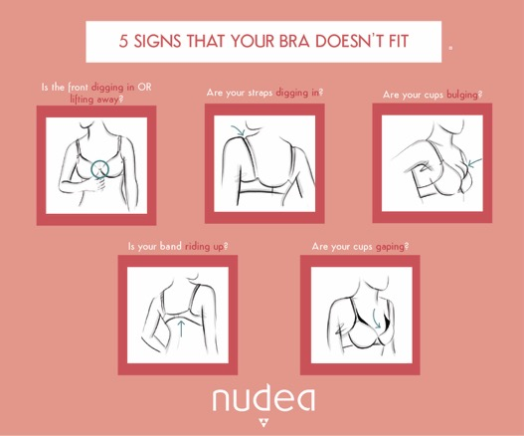

Nudea’s expertly crafted, comfortable lingerie in contemporary, feminine designs embraces a more modern, body-positive attitude for everyday performance and comfort. With no overhyped technology, no simplifying design and no shortcuts, Nudea brings together the best of moulding, bonding and quality fabrics to engineer better underwear.

-ENDS-
Contacts:
Claire Russell, Park PR, e: parkpr@outlook.com ph.: +44 7759 221780
www.nudea.com Follow us @nudealingerie
Notes to Editors:
- Nudea campaign and cut out images are available to download from:
https://www.dropbox.com/sh/q4xfs4yh57zjdv1/AAAMi8L4i7L5HDdzpj4jLWmRa?dl=0
- Nudea’s three debut collections are available online at www.nudea.com. Launching initially with 27 bra sizes ranging from 30A to 38E and knickers available in 7 sizes ranging from XXS to XXL.

About Nudea:
Nudea founders Priya and Sophie were uninspired by the uncomfortable and old fashioned bras that they found in their lingerie drawers, so they decided to envision their own brand that was built around the modern woman and her lifestyle. And so Nudea was born. Direct to consumer and online-only, Nudea is breaking industry norms by modernizing the measuring process, with a true focus on user experience and customer satisfaction – from initial online browse through to delivery. With no overhyped technology, no simplifying design and no shortcuts, Nudea brings together the best of moulding, bonding and quality fabrics to engineer better underwear.
* Nudea conducted extensive research of over 600 British women in a pioneering size and fit research and development process. For full findings from this research, please contact Claire Russell at Park PR, e: parkpr@outlook.com
- One of the key reasons is that two-thirds of women reported having had a body change (weight loss/ gain/ pregnancy/ surgery) in the previous six months, yet less than 20% had been measured for a bra in the past year despite these changes having a direct effect on their bra size.
- 50% of women surveyed hadn’t been measured for a bra for over 5 years.
- Only 8% of women claimed to have no issue with their bra, which means that 92% see room for improvement.
- Only 10% of women measured themselves to the correct size vs. a professional bra fitter. 11% were just one size out but a massive 79% of women were wearing both the wrong band and cup size.

